***Supplementary Materials – Word File***

**Optimizing Fish Conservation in a Multiuse Marine Protected Area with Functional Ecology**

**Rodrigo Alfredo Núñez-Inzunza1*, Johanna Calle-Triviño2, Camilo Cortés-Useche2, Jesús Ernesto Arias-González*1**

**\*Correspondence:** [rodrigo.nunez@cinvestav.mx](mailto:rodrigo.nunez@cinvestav.mx), [earias@cinvestav.mx](mailto:earias@cinvestav.mx)

**Note S1. Complimentary calculations of diversity measures based on Hill numbers**

The Hill number $q_{Δ}$ for incidence data is interpreted as the effective number of equally frequent species in the set from which the sampling units are extracted. That is, if $q_{Δ}$ *= y*, then the diversity of the assemblage is the same as that of an idealized assemblage with y species all equal probability of incidence (Chao et al. 2014):

$$q_{∆}={\left({\sum_{i=1}^{S}{\left[\frac{π_{i}}{\sum_{j=1}^{S}{π_{j}}}\right]}}^{q}\right)}^{1/(1-q)} q≥0 q≠1.$$

The previous equation gives the species richness for incidence data when q = 0, there is a limit of *qΔ* when q tends to 1 and gives:

$1_{∆}=\lim{q_{Δ }}=exp⁡\left(-\sum_{i=1}^{S}{\frac{π_{i}}{\sum_{j=1}^{S}{π_{i}}}\log{\frac{π_{i}}{\sum_{j=1}^{S}{π_{i}}}}}\right)$

**Table S6.** Multidimensional functional alpha-diversity indices.

|  |  |  |
| --- | --- | --- |
| Name | Formulae | Statistical Definition |
| Functional Richness  (Villéger et al. 2008) | (1) $FRic$ = ∑ $n_{i}$ | The volume of the convex hull that shapes the species present in the set. |
| Functional Identity (Mouillot et al. 2013) | (2) $FIde= ∑{(\frac{n_{i}}{S})}^{2}$ | The weighted average position of the species in the set along each axis. |
| Functional Dispersion (Laliberté & Legendre 2010) | (3) $FDis=1- ∑{\left(\frac{n_{i}}{S}\right)}^{2}$ | The weighted deviation from the center of gravity (i.e. defined by the FIde values) of the species in the set. |
| Functional Divergence  (Villéger et al. 2008) | (4) $FDiv=\frac{\left(1- ∑{\left(\frac{n_{i}}{S}\right)}^{2}\right)}{\left(1- ∑{\left(\frac{n_{i}}{FE}\right)}^{2}\right)}$ | The deviation of biomass-density from the center of gravity of the vertices that make up the convex hull of the studied set. |
| Functional evenness (Villéger et al. 2008) | (5) $FEve=\frac{\left(∑{\left(\frac{n_{i}}{S}\right)}^{2}\right)}{\left(∑{\left(\frac{n_{i}}{FE}\right)}^{2}\right)}$ | The homogeneity of the distribution of biomass density along the minimum spanning tree (i.e. the tree that connects all the species in the set with the least accumulated branch length) for the studied set. |
| Functional Originality (Mouillot et al. 2013) | (6) $FOri=1-(∑\frac{{n_{i}}^{2}}{S^{2}})$ | The weighted average distance to the nearest species from the global set of species. |
| Functional specialization (Bellwood et al. 2006, Mouillot et al. 2013) | (7) $FSpe=1-{∑\left(\frac{n_{i}}{S}\right)}^{2}$ | The weighted average distance to the nearest species from the global set of species. |
| Functional mean pairwise distance (Weiher et al. 1998) | (8) $FMPD=\sqrt{\left[\frac{1}{S}*\frac{∑\left(n_{i}*∑\left(n_{j}*d_{ij}\right)\right)}{(S-1)}\right]}$ | The weighted average distance between all pairs of species. |
| Functional mean nearest neighbor distance  (Weiher et al. 1998) | (9) $FNND=\frac{(∑d_{i})}{\left(S*(S-1\right))}$ | The weighted distance to the nearest neighbor within the set. |
| Functional alpha diversity based  in Hill numbers  (Chao et al. 2019) | (10) $FDq=∑{i=1}^{S}{\left(\frac{n_{i}}{N}\right)}^{q}$ | The Hill number of functional diversities of order q, where $n_{i}$ is the number of species in the i-th functional entity. |

**Note S2.** Functional traits considered to create the functional entities for functional diversity indices (Mouillot et al., 2014):

* **Size** is coded as an ordered categorical variable with 6 levels:

1= 0-7cm (S1)

2= 7,1-15cm (S2)

3= 15,1- 30cm (S3)

4= 30,1-50cm (S4)

5= 50,1-80cm (S5)

6= >80cm (S6)

* **Mobility** (= Home Range) coded as an ordered categorical variable, with 3 levels:

1= Sedentary (Sed)

2= Mobile within a reef (Mob)

3= Very mobile, i.e., between reefs (VMob)

* Period of **Activity** coded as an ordered categorical variable, with 3 levels:

1= Diurnal (Day)

2= Diurnal and nocturnal (Both)

3= Nocturnal (Night)

* **Schools** coded as a categorical variable, with 5 levels:

1= Solitary (Sol)

2= In pairs (Pair)

3= Small group (SmallG)

4= Medium group (MedG)

5= Large group (LargeG)

* **Position** in the water column is coded as an ordered categorical variable, with 3 levels:

1= Bottom (Bottom)

2= Above the bottom (Low)

3= Pelagic (High)

* **Diet** coded as a categorical variable, with 7 levels:

HD = Herbivore-detritivores (undefined organic matter, often grouped together by many authors under the name of detritus and/or undefined vegetable matter, grass, or filamentous algae).

HM = Macroalga herbivores (large fleshy algae and seagrasses).

IS = Sessile invertebrate feeders (sessile invertebrates: corals, sponges, ascidians, among others).

IM = Mobile invertebrate feeders (large benthic invertebrates + small benthic invertebrates + undefined invertebrates).

PK = Planktivores (plankton and small organisms that migrate in the water column, such as many benthic copepods, amphipods, crustacean larvae, etc. that migrate in the water column at night).

FC = Pelagic macroorganisms (large organisms living in the water column, normally fish and cephalopods) and benthic fish.

OM = Omnivores (herbivores and/or detritivores and carnivores).

Formulae for Functional Redundancy, Functional Overredundancy and Functional Vulnerability based on FEs as in Mouillot et al. (2014).

Where S is the total number of species in the sites, FE is the total number of functional entities and $n_{i}$ is the number of species in the *FE $i$* :

$FRed=\frac{\sum_{i=1}^{FE}{n_{i}}}{FE}=\frac{S}{FE}$

$FVuln=\frac{FE-\sum_{i=1}^{FE}{min⁡(n_{i}-1,1)}}{FE}$

$FOred=\frac{\sum_{i=1}^{FE}{\left[\max\left(n_{i},FRed\right)-FRed\right]}}{S}$

**Figure S1.** Quality of multidimensional spaces based on PCoA according to the deviation between trait-based distances and functional space distances. Raw deviation (Dev. Raw) and absolute deviation (Dev. Mad) of distances only for the dendrogram and 2D, 3D, 4D spaces.

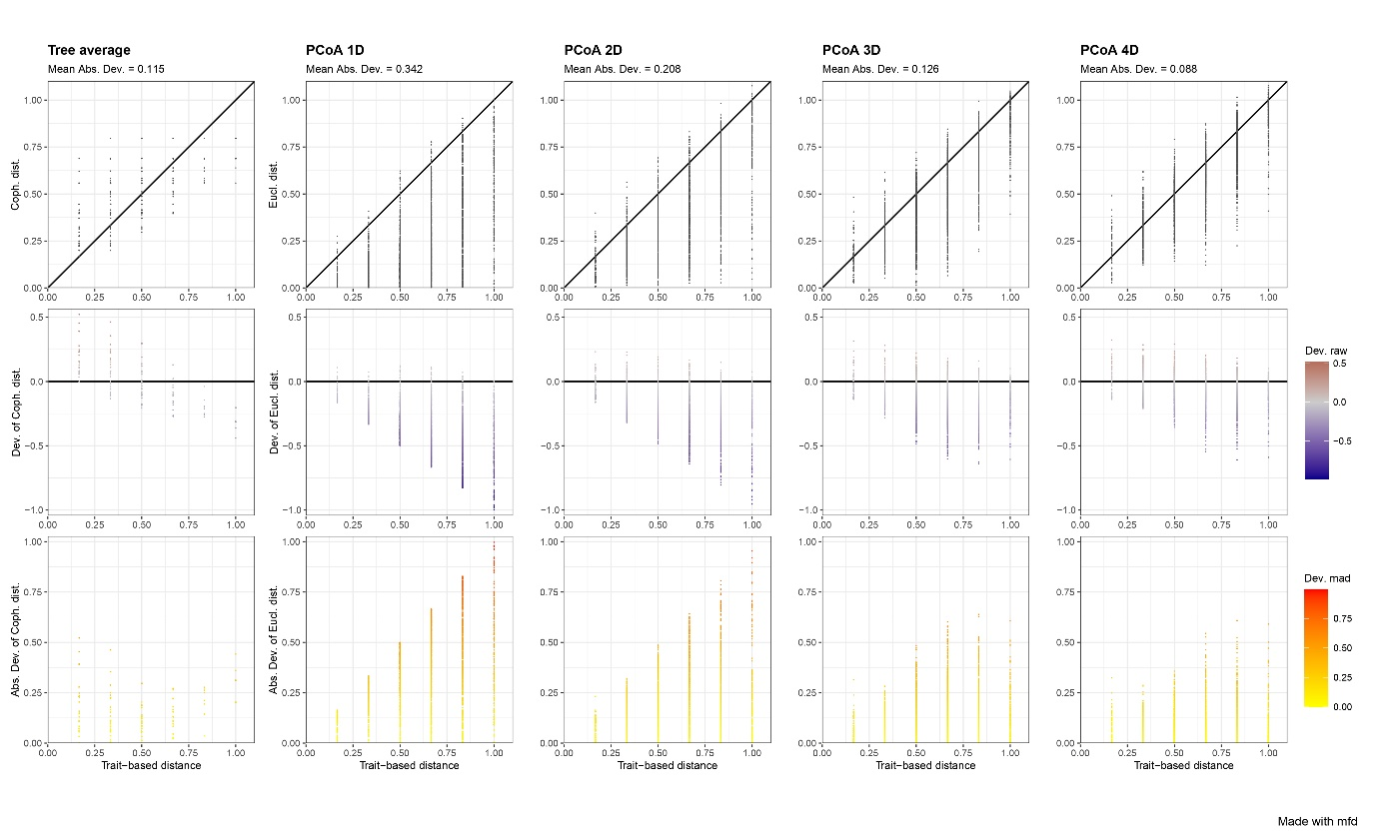

**Figure S2.** Tests of relation between PCoA axes and functional traits. For continuous traits, a linear model is calculated and $r^{2}$ and the associated p-value are obtained. For non-continuous traits, a Kruskal-Wallis test is calculated and the $η^{²}$ statistic is returned.

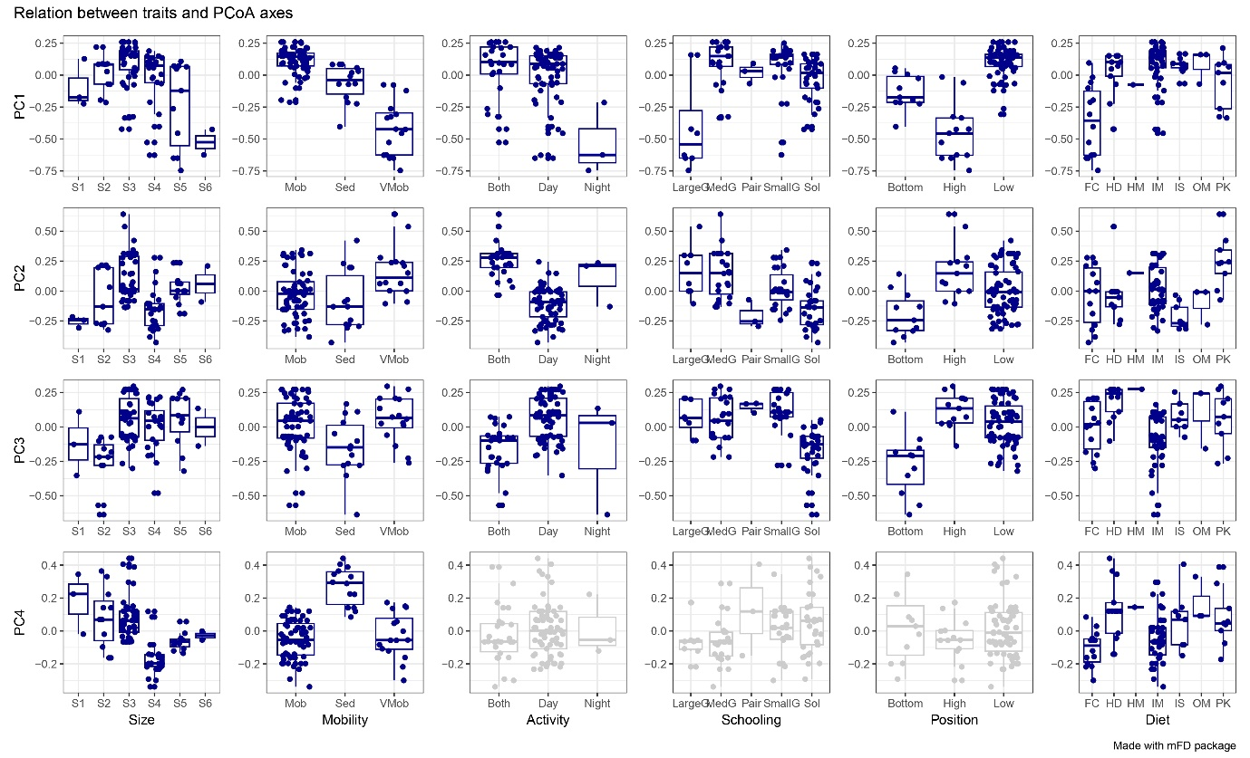

**Supplemental Material Literature Cited**

Chao, A., Gotelli, N. J., Hsieh, T. C., Sander, E. L., Ma, K. H., Colwell, R. K., Ellison, A. M. (2014). Rarefaction and extrapolation with hill numbers: a framework for sampling and estimation in species diversity studies. Ecological Monographs, 84(1), 45-67. https://doi.org/10.1890/13-0133.1

Magneville, C., Loiseau, N., Albouy, C., Casajus, N., Claverie, T., Claverie, T., Escalas, A., Leprieur, F., Maire, E., Mouillot, D., Villéger, S. (2022). mFD: an r package to compute and illustrate the multiple facets of functional diversity. Ecography, (1): e05904. https://doi.org/10.1111/ecog.05904

Mouillot, D., Villéger, S., Parravicini, V., Kulbicki, M., Arias-González, J. E., Bender, M., Chabanet, P., Floeter, S. R., Friedlander, A., Vigliola, L., Bellwood, D. R. (2014). Functional over-redundancy and high functional vulnerability in global fish faunas on tropical reefs. Proceedings of the National Academy of Sciences. 111(38):13757- 13762. https://doi.org/10.1073/pnas.1317625111